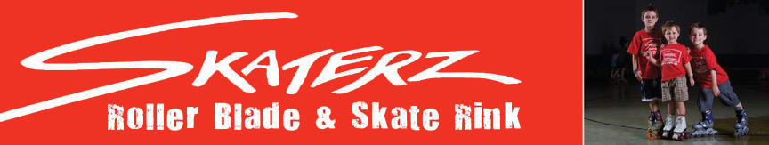

Banyule Cub Scouts have been asked to try out a new program and that’s a SLEEPOVER at the SKATERZ
Skaterz - 27 Susan St, Eltham - - Melway Ref 21H7
Date 21st MAY
Time 6 pm Saturday, till 9 am Sunday
The night will include
Skate time
Movie (PG)
Disco
And even a skating demo from the Eltham Artistic Skating Club
With bacon and eggs or cereal for breakfast

We have very limited sleeping spaces so be first in for the best spot on the floor
You will need to bring dilly bags, sleeping bags and bedrolls
The cost for the night is $25 including skates, safeguards and breakfast
You can bring up to $10 spending money if you would like to
________________________________________________________________________

My cub from Rosanna Cub Pack will be attending

His/her name is __________________________

Money paid $__________ **Health Forms will be sent to attendees and must be
brought on the day

Please email me details to akela@rosannacubs.org
AND bring forms & money to Cubs by Tuesday 10th May at the latest.
Any queries, please call Akela – 9434 7594 or 0411 121 495

